**Assignment to Design Twitter System:**

**Twitter Database Schema:**

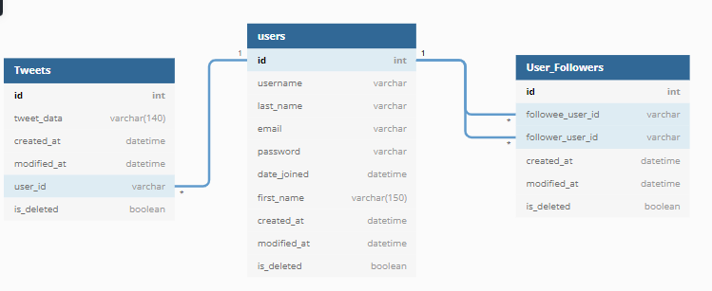

**API:**

* **Unauthenticated user - Create user (Signup):**
  + **POST** signup\
    - Username:
    - Emailaddress:
    - Password:
  + Validate the data and then add record in the Users table
* **Authenticated user:**
  + **Get** homepage\
    - Fetch all recent tweets made by the followees (people this user follows) of the logged in user
    - (**@user_id** = request.user.id)
    - (select tweet_data from tweets where user_id in *(select followee_user_id where followee_user_id =* ***@user.id****)*
  + **POST** follow\{user_id}
    - Add entry in the User_Followers table with
    - followee_user_id = {user_id}
    - follower_user_id = **@user_id**
  + **POST** tweet\
    - (with tweet message in request body)
    - Add entry in the tweets table

**Scalability and High level considerations:**

* Set up Load Balancer: Handle incoming requests better
* More reads expected than writes to the DB hence multiple read databases should be available
* Eventual consistency seems optimal choice as availability is important
* DB can be replicated (for better performance and fault tolerance)
* **Issues might arise when user has lot of tweets to be fetched – which are posted by follwees**
  + For improvements - we can setup another DB and keep adding tweets posted by the followees and store in a faster **NoSQL cache DB, use this DB to fetch timeline for the user**
  + This will reduce timeline load time as it would be present in the cache DB while using pre-processing approach